Required practical activity: Basic Neutralisation
Practical Guide – Basic Neutralisation

Aim: To use a colour-changing indicator to find the reacting volumes of solutions of a strong acid and alkali
Notes and guidance
You may wish to have students collect the equipment for this themselves from communal trays at the front of the lab. This will help them to develop their skills of equipment recognition and organisation. However, if this is impractical, ask your technician colleagues if they can set up individual sets at student workstations.

This practical is a very basic version of a titration. You may wish to demonstrate the use of a burette to prepare them for GCSE-level practical work.

If students are working in groups, encourage each member of the group to carry out a titration during the lesson. This is a relatively simple practical and students should be able to complete it relatively quickly.

Risk Assessment Notes
A risk assessment must be completed for this practical. The risk assessment should be specific to the class involved and written only by the teaching member of staff. For more guidance refer to CLEAPSS. It is good practice for students to wear safety spectacles during all class practicals and demos.

0.1 M hydrochloric acid is not currently classed as a major hazard. However, it can cause mild irritation so ensure eye protection is worn at all times. For waste disposal, pour down a foul-water drain with plenty of water. Refer to CLEAPSS Hazcard 98A.

0.1 M sodium hydroxide solution is currently classed as an irritant and a cause of skin and eye irritation. Take care while handling it and wear eye protection. For waste disposal, pour down a foul-water drain with plenty of water. Refer to CLEAPSS Hazcard 91.

Equipment Per Group | Equipment Per Group  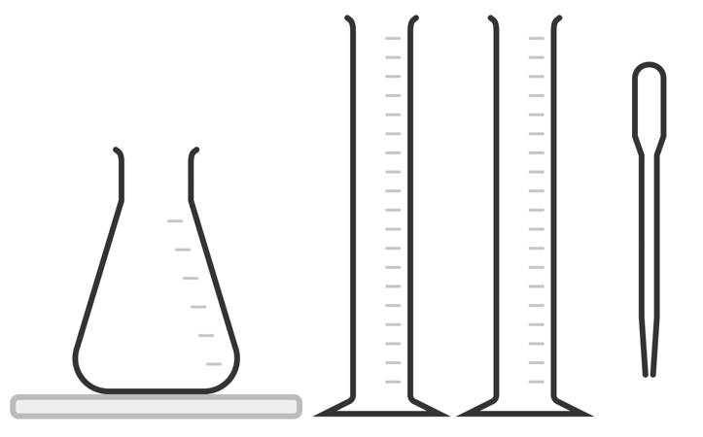  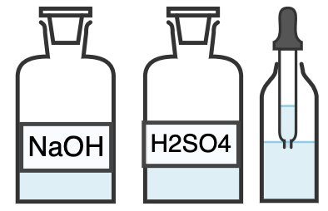  (Phenolphthalein)  HCl
Apparatus:
- 250 cm³ conical flask
- 2 x 100 ml measuring cylinder
- White tile
- 1 ml dropping pipette

Chemicals:
- 0.1 mol/dm³ sodium hydroxide solution (irritant)
- ‘Unknown concentration’ hydrochloric acid
- Phenolphthalein indicator

Method |  | Questions To Ask Students During The Practical
- Add 25 cm³ of sodium hydroxide solution to the conical flask using the measuring cylinder.  - Add 5 drops of phenolphthalein indicator to the 0.1 M sodium hydroxide in the conical flask. Gently swirl the flask and the contents will turn pink.  - Place the conical flask on a white tile.  - Use the second measuring cylinder to add 40 cm³ of ‘unknown’ hydrochloric acid solution to the conical flask.  - Use the 1 ml pipette to add more hydrochloric acid to the conical flask, 1 ml at a time. Eventually, one of these drips will cause the colour a colour change from pink to clear. At this point, ensure no more hydrochloric acid is added.  - Record the total volume of hydrochloric acid required to neutralise the solution on your table.  - Repeat the experiment two more times and complete your table. Calculate the mean volume of hydrochloric acid needed to neutralise 25 cm³ of 0.1 mol/dm³ sodium hydroxide. |  | - Why do we constantly swirl the conical flask? (To ensure all of the solution has reacted.)  - Why do we use a white tile beneath the conical flask? (To best see the colour change of the solution.)  - Why do we add the hydrochloric acid solution slowly? (So as to not miss the exact point at which the solution in the conical flask is neutralised.)  - What colour change does the phenolphthalein indicator exhibit? (It goes from a transparent appearance when neutral or acidic to purple when alkaline.)
Phenolphthalein Indicator Colour Change:
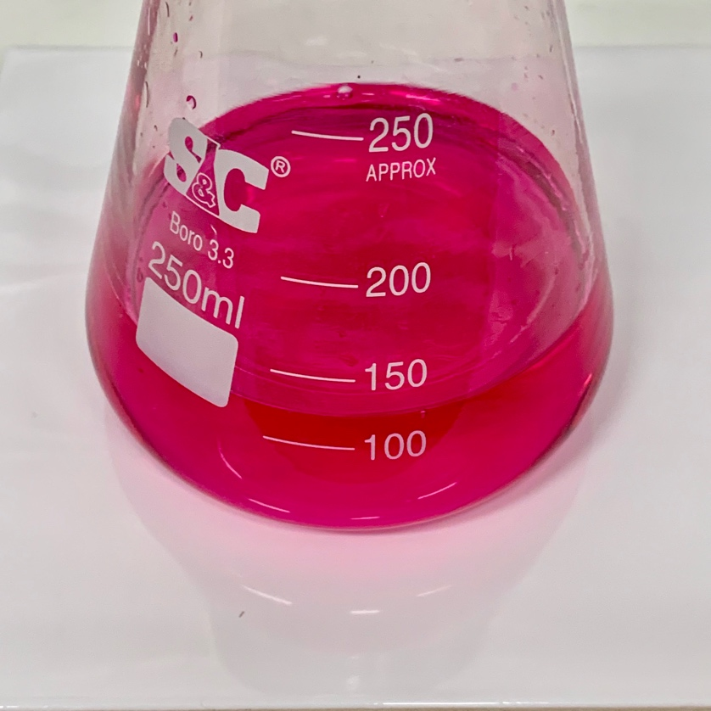
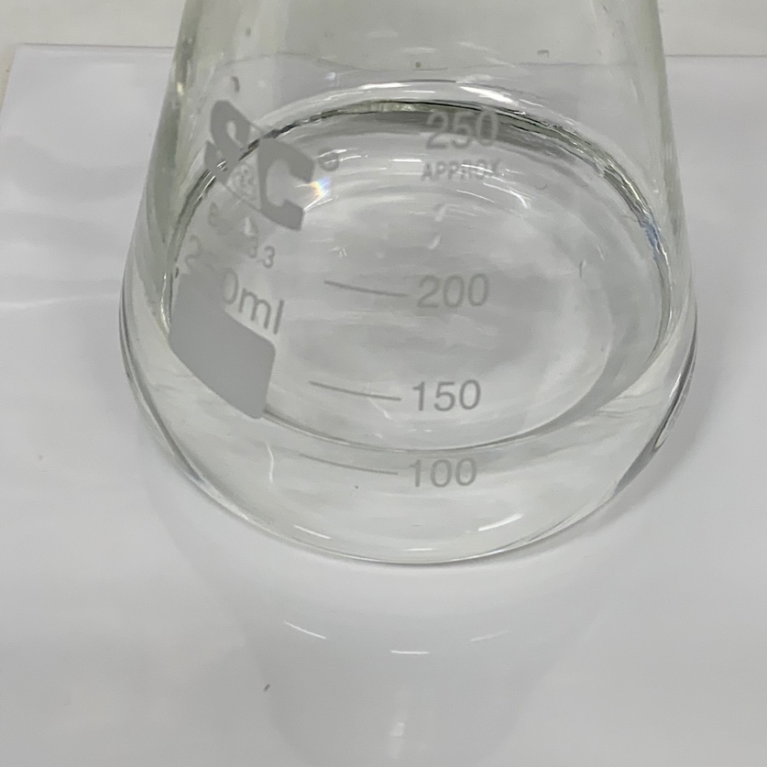

Neutral/Acid
Alkali

Alternative Methods/Computer Simulations |  | Clearing up
If time is available, you may wish to demonstrate this practical with another indicator. Sometimes, an exam question may refer to, for example, methyl orange indicator and if students have only ever seen the pink/transparent phenolphthalein, they may be more likely to get confused.  The acid/base being neutralised can be substituted, but ensure the strengths of the chemicals used are similar so as to not require an excessive volume of either.  This experiment can be conducted using two less-than-half-full measuring cylinders of the solutions. First, record the starting volume of the hydrochloric acid and add the indicator to the sodium hydroxide solution. Then, use a pipette to add hydrochloric acid to the sodium hydroxide. When the indicator turns clear, squirt any remaining acid from the pipette back into the measuring cylinder and record how much has been used. |  | It is important that equipment is returned to the prep room in good order. If safe to do so, rinse used equipment and put it in the used equipment tray. If the trays arrived on a trolley, students must return all trays and equipment to that trolley. Anything dirty needs to be placed into a separate container for washing up. Never put dirty equipment back into a tray with clean equipment.
Questions To Ask Students During The Analysis
Why do we run numerous titrations and take the mean result? (To minimise the effect of human error or anomalous results.)
What is the concentration of the ‘mystery’ hydrochloric acid? (Approx. 0.1 M.)

Technician Notes
Ensure the solutions you provide are free from contamination and the equipment is as clean as possible.

Consult CLEAPSS Hazcards if making up sulfuric acid and sodium hydroxide solutions from more concentrated solutions. Always add concentrated acid to water and not the othe way around.

Though students will inevitably be somewhat inaccurate in their method, it is important to make the solutions as accurate to the ordered concentrations as possible, and it is best to make them fresh with a volumetric flask. Older solutions may have become contaminated or lost strength over time and lead to inaccurate results.

Discuss this practical with the class teacher ahead of time. Ensure they have considered the risks of this practical and are confident with the techniques used. If necessary, provide them with the CLEAPSS hazcards (identified in the risk section section above) so they are comfortable with the chemicals to be used and how to use and dispose of them safely.

